The Eye

Use the information on the laminated
card to identify the parts of the eye
and their function.

 | Name of Part | Function of Part
A
B
C
D
E
F
G
H
I
J
K
L
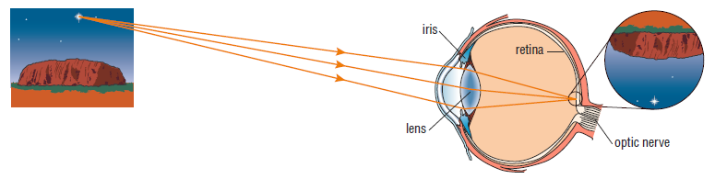
The eye focuses images onto the retina. Although the image is upside down, the brain processes it so that we perceive it the correct way up.

Use page 138 of the Pearson Science Student Book to answer the following questions.
The lenses in your eyes focus on objects at different distances by changing focal length
- Describe how your eye is able to focus on distant objects. Use a diagram to support your answer.

- Describe how your eye is able to focus on close objects. Use a diagram to support your answer.

- What is the ability of the lens to change shape called? What happens as we get older?

Vision problems
- If light is not focused to a point on the retina, then a person will not see a clear image. Describe two common vision problems caused by the image not forming on the retina.
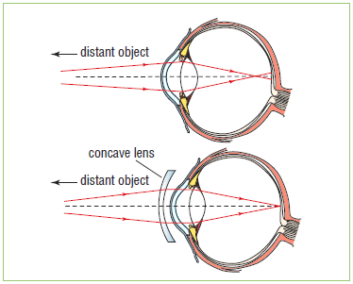
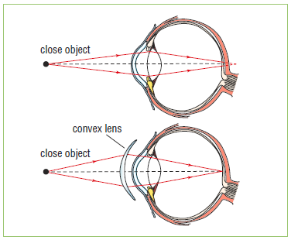

short-sightedness (myopia) long-sightedness (hyperopia)

- People who have more than one vision problem often use bifocals. Describe how these work.

- Describe two other methods for correcting vision problems.

